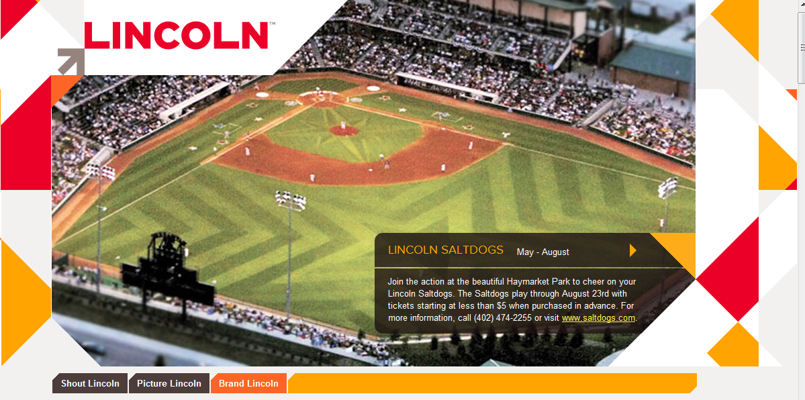

The Lincoln Brand
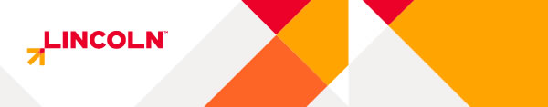
The rest of the world may not know it, but our city has the perfect mix of good people, interesting places and a diverse range of things to do. We've quietly kept Lincoln a hidden gem, an intriguing city in an unexpected place. But now that our city is undergoing its greatest period of growth it's ever seen, the time is now to build a unified vision for the city and to capture this immense momentum.

Target Audience + Brand Support
We want to talk to the groups that represent the future of Lincoln. These leaders, young professionals and university students need to know what those who live here already know about Lincoln:
- You can be successful in Lincoln
- You can be comfortable in Lincoln
- You can have fun in Lincoln.
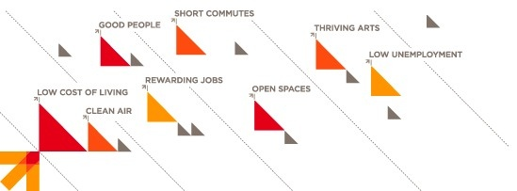

Brand Personality
What does this mean? When you take it at its essence, life just... feels right in Lincoln. All the factors that lead to a great life can be found right here. You can enjoy an incredible work/life balance that will enable you to make your own success. And you'll feel comfortable doing it and have fun all along the way.
Life is Right in Lincoln isn't a slogan. It's a platform for conversations around the brand. It's the sweet spot that defines the sentiment of those who live here.
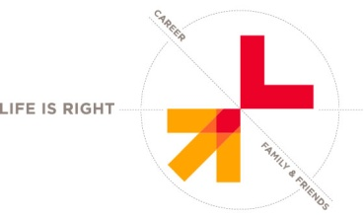

The Lincoln Brand
The Lincoln logo mark is intentionally simple, not trendy. It's classic form should last a long time. But what does the mark represent?
- The arrow points upward and to the right to symbolize growth and progress. By pointing to the Lincoln (the "L") the logo creates an intersection, the sweet spot that signifies that life is right in Lincoln.
- The three portions of the arrow represent Lincoln in two ways. From a rational perspective, they stand for the people, places and events that make up our community. From an emotional perspective, they stand for the success, comfort and fun you can have when you live in Lincoln.
- The brand colors signify a progressive future for Lincoln. The red is an acknowledgement of the presence and impact the University of Nebraska-Lincoln has on our city.
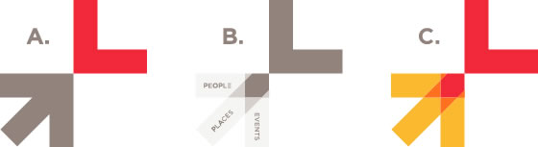

It's Your Brand, Too!

The Lincoln brand was developed with a system that allows local business owners and organizations of all types to customize and integrate it into their business or campaigns. For example, SHOP-LINCOLN could work for a retailer initiative, WORK-LINCOLN for employment/careers, DINE-LINCOLN for restaurants, etc. Have an idea for an extension? Check out the Brand Portal.
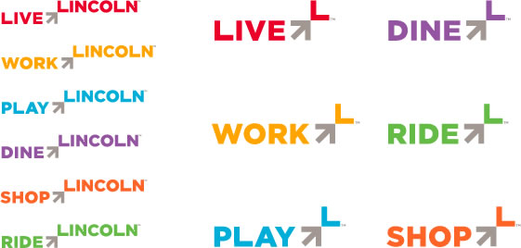

The Lincoln Brand

The visual identity of the Lincoln brand is just the beginning. There is so much more that goes into the expression of a brand! We're working with local businesses and other organizations to implement a number of fun initiatives for the city that will make the brand not only seen, but felt. Be sure to sign up to get notified on these exciting developments.
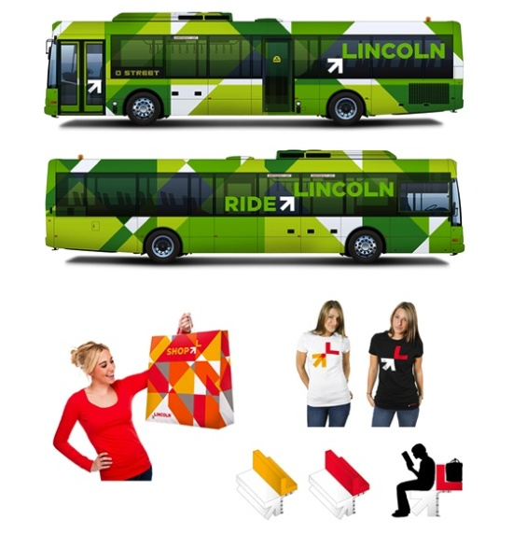

BRAND ASSETS
We think the brand would look good on you. For information on how you can incorporate the brand into your business, event or campaign fill out the information below and we'll work together to make it happen.

