Name_________________________

Answer Below
A record keeping device called a _______________________ records checks paid and deposits made by companies using a checking account.

A _________________ is used to add funds to a bank account

The numbers listed at the bottom of a check are the ________ number and the _______ number.

The U.S. banking system, called the Federal Reserve, includes the Reserve Banks, the Federal Open Market Committee, and _________.

A service charge on your bank statement will result in

What is the penalty for using the ATM of a bank that is not your bank?

What type of bank account offers the most flexible access to your money with the fewest restrictions?

What type of bank is ran by its members, offers low rates of interest, and limits membership to certain groups of people or groups?

_____________________ is the process of comparing the bank balance to the checkbook balance.

What is an example of earned income?

When your paycheck goes into your bank account and does not require an endorsement from you each pay period.

What is an advantage of online bill paying?

What is Opportunity Cost?

Define the Following

ATM (Automated Teller Machine)

Overdraft Charge

Online bill pay

Outstanding Check

Endorsing a check

Debit card
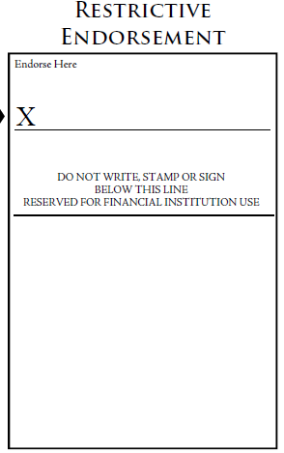
Fill out the Following

Write a restrictive endorsement to account 303177

Cash $33.50
One check, written on check No. 1778, for $61.50
Second check, written on check No. 665 for $24.50
No “Cash Received”
Use today’s date.

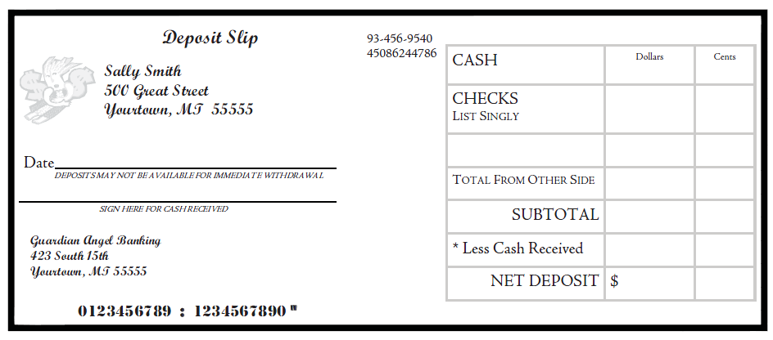
Write a check to Ruza for $9.50 for Lunch today. Use today’s date

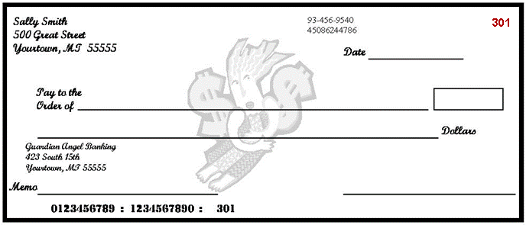

KEEPING A CHECK REGISTER

24. Given the following information, enter the transactions in to the check register and calculate the running balance. (9 points)

9/1 Beginning Balance $500.92
9/3 Check #501 written to Verizon Wireless $81.22
9/5 Debit Card Transaction at Wal-Mart $34.51
9/10 Paycheck Deposit $210.10
9/12 Check #610 written to Brent J $50.04

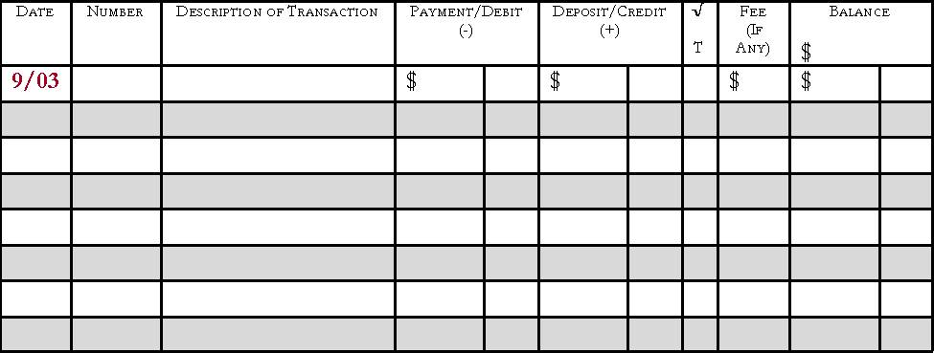

RECONCILING (BALANCING) A BANK STATEMENT

25. On July 31, your check register balance is $2,660.07 and the bank statement shows a balance of $2,921.01.

After comparing records you find an outstanding deposit of $217.19.

The following checks are outstanding.
392……411.10
395……. 57.08
396…….. 9.95

Prepare the following bank reconciliation. (9 points)

