- Start Photoshop
- Open the Fizzy Root Beer File
- Hide the label layer. Select the background layer. Click D key to reset the default colors
- Go to Filter Menu, Click Convert for Smart Filter.
- To simulate a bubble look, apply the Render filter named Clouds.
- Apply the stylized filter named Glowing Edges, Setting the edge width to 3, the edge brightness to 19, and smoothness to 15.
- Apply sketch filter named plaster, setting the Image Balance to 16 and the smoothness to 2
- Next, to make the bubbles look like liquid, add a lighting effect. On the filter menu point to the Render, and click Lighting Effects. Choose Blue Omni for the style.
- Drag center point to the lower-left corner and click OK to close the lighting effects dialog box.
- Apply the sketch filter named Chrome, setting detail to 8 smoothness to 10.
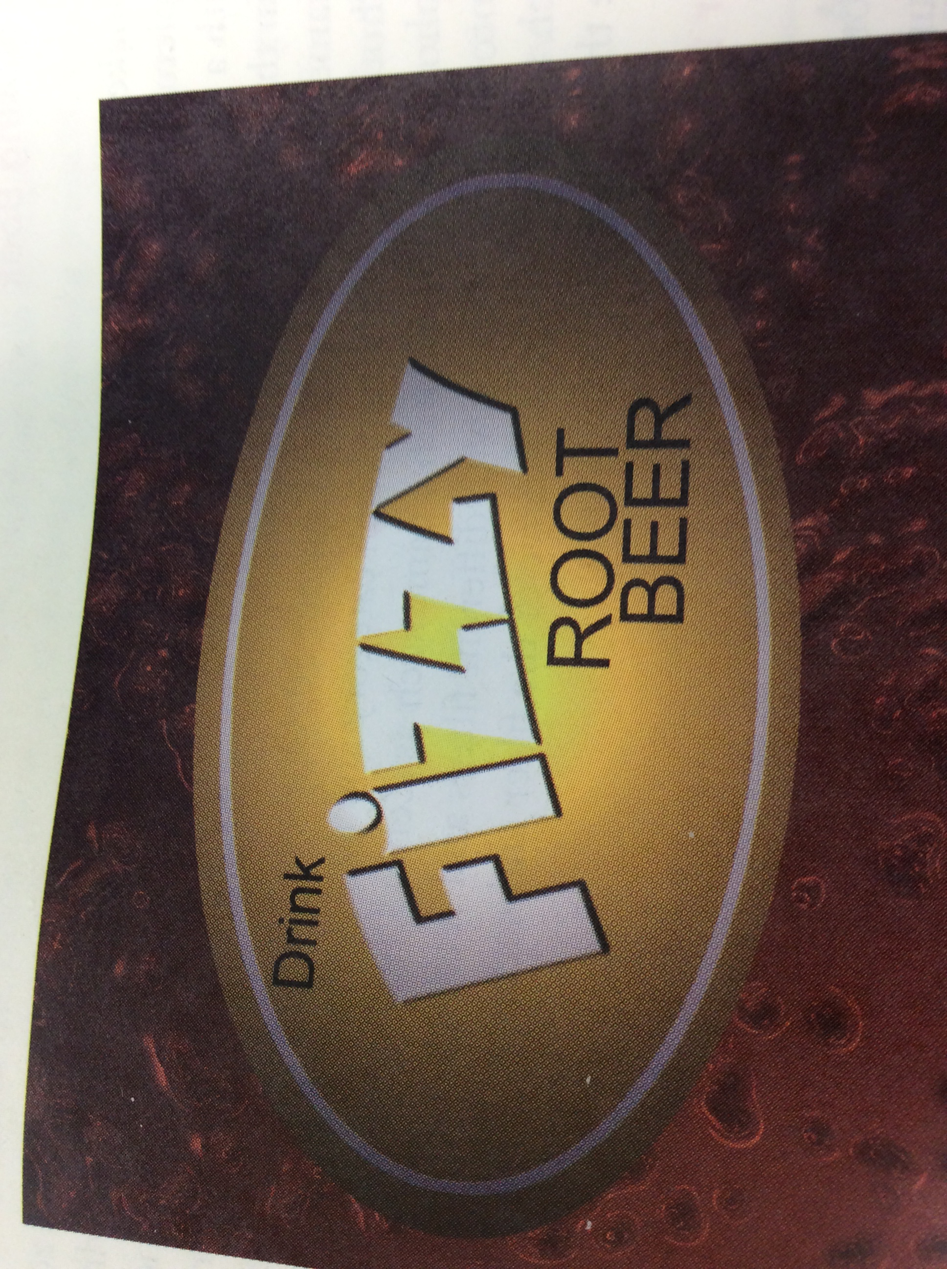
- To make Bubbles Brown, Click Hue/saturation on the adjustment panel to open the properties panel. Select the colorized check box so that it displays a check mark, st hue to 22 and saturation to 70, and lightness to -25. Click on the “clip to layer” Button on the properties panel,
- Save as FizzyRootBeer.jpeg

