Business Economics Name: ________________________________
Chapter 13 Section 3

Aggregated Demand____________
Law of Demand__________
Aggregate Supply_________
Equilibrium Price_______

Business Economics
Chapter 13 Section 4
Business Fluctuations

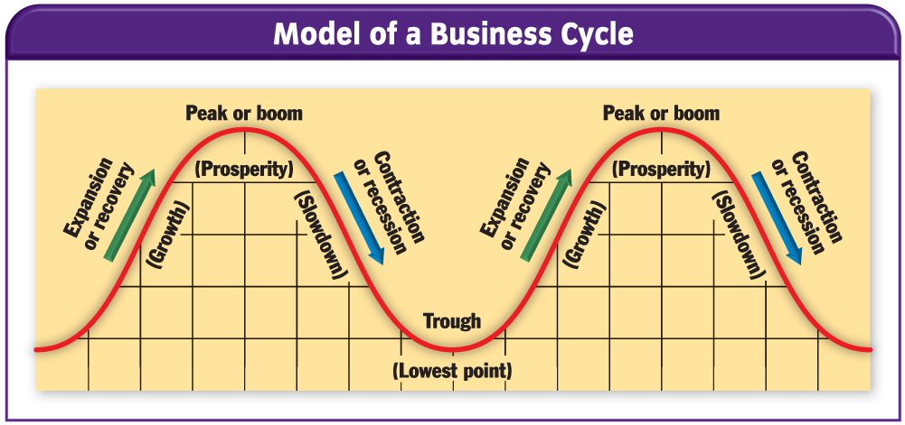

Depression: ______________________________________________________________________________________________________
___________________________________________________________________________________________________________________
___________________________________________________________________________________________________________________

What is a Peak or boom____________________
Expansion or Recovery____________________
Contraction or Recession________________
Trough____________________
Depression____________________

What factors might cause a recession to deepen to a depression? _______________________________________
__________________________________________________________________________________________________________________
__________________________________________________________________________________________________________________

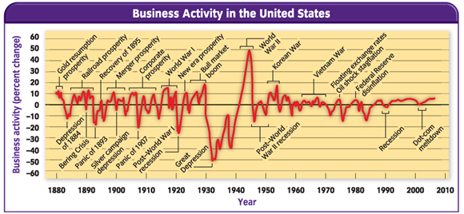

Business Economics
Chapter 13 Section 5
Causes and Indicators of Business Fluctuations
